|  |
| --- |
| GUI BASED ROBOTIC CAR |

|  |
| --- |
| SUBMITTED BY:  MUHAMMAD HASSAN [2017-EE-069]  AAZIB AHMED ANSARI [2017-EE-078]  MIRZA HAMZA UMER [2017-EE-079]  MUHAMMAD USMAN [2017-EE-107] |

|  |  |
| --- | --- |
| SUBMITTED TO:  Ms. RAZIA ZIA | colored transparent rectangle |



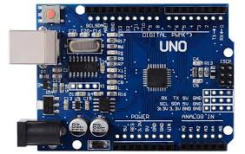

GRAPHs & CALCULATIONS

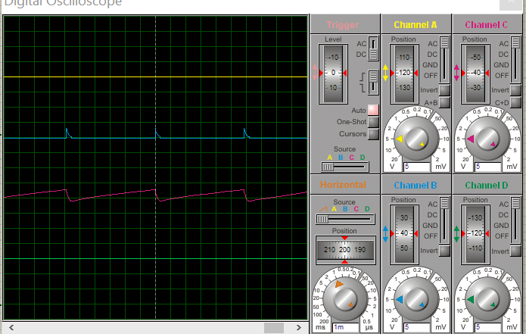

CALCULATIONS:

|  |
| --- |
| INTRODUCTION TO THE PROJECT |

|  |
| --- |
| INTRODUCTION: Here we are using a UJT (Uni-Junction Transistor) which is used here for switching oscillator purpose which will generate the saw-tooth pulse which is given to the SCR to vary the speed of the DC-motor by using a thermistor.   COMPONENTS:UNI-JUNCTION TRANSISTOR: The UJT is a three-terminal, semiconductor device which is used for the switching purpose and to produce oscillations. THYRISTOR or SCR: It is a multi-layer semiconductor device, abbreviated as SILICON CONTROL RECTIFIERS. These are very handy solid state devices for controlling AC motors, lamps and for phase control by using the gate terminal giving a pulse on it. THERMISTOR: An electrical resistor whose resistance is greatly reduced by heating, used for measurement and control. FREE WHEELING DIODE: It is used secure the circuit from the back emf of the motor. DC-MOTOR: Used as load here which speed is controlled through DC input. |
| **WORKING:**  The silicon controlled rectifier SCR, is one of several power semiconductor devices along with Triacs (Triode AC’s), Diacs (Diode AC’s) and UJT’s (Unijunction Transistor) that are all capable of acting like very fast solid state AC switches for controlling large AC voltages and currents. So for the Electronics student this makes these very handy solid state devices for controlling AC motors, lamps and for phase control.Using the circuit above, we can control the speed of a universal series motor (or whichever type of load we want, heaters, lamps, etc) by regulating the current flowing through the SCR. To control the motors speed, simply change the frequency of the sawtooth pulse, which is achieved by varying the value of the potentiometer.  Here we have given 18V at input side which drive the potientiometer and charges and discharges the capacitor the variated voltage from potentiometer is given to the emitter of ujt which produces a sawtooth pulse which is given at the gate of SCR which drives the motor as we change the voltage through the potentiometer the speed of the DC motor will vary.  **CIRCUIT DIAGRAM:** |

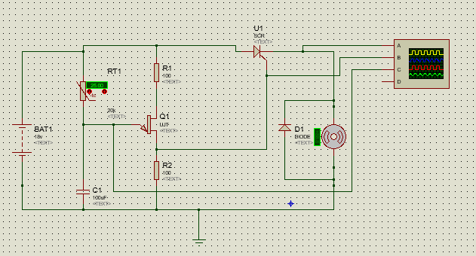

|  |
| --- |
| CONCLUSION |

|  |  |
| --- | --- |
| We have achieved the required speed simply using a Thyristor and a UJT and therefore this is the very simple technique to control the speed of DC motor by varying the DC voltage.  There is the very vast applications of this projects such that in robotic arm, swing machines, electric bikes, DC operated drill machines, toys, electric door controls , etc.    If we talk about the future enhancement of our project so we can connect our circuit with wifi module to control the speed of DC motor wirelessly. |  |
|  |